Telusko: Advance Java 06

172 SpringBoot logging using SL4J, SpringBoot Logging using log4j2

Saturday,Sunday(9.00AM to 2.00PM IST)
=====================================
SpringDataJPA
SpringBootMongoDB
Tuesday,wednesday,Thursday(6.30AM to 9.30AM)
============================================
SpringAOP
SpringSecurity
SpringMail
SpringBoot using Log4j
======================
Logger levels of SL4J are
=> debug<info<trace<warn<error
=> By default SpringBoot uses SL4J with log4j to generate the log messages
=> <dependency>
<groupId>org.springframework.boot</groupId>
<artifactId>spring-boot-starter</artifactId>
</dependency>
DotNetCourseMaterial.java
=========================
@Component(value = "dotNet")
public final class DotNetCourseMaterial implements ICourseMaterial {
}
JavaCourseMaterial.java
=======================
@Component(value="java")
public final class JavaCourseMaterial implements ICourseMaterial {
}
Student.java
============
@Component(value = "student")
public class Student {
private Logger logger = LoggerFactory.getLogger(Student.class);
@Autowired
@Qualifier("courseId")
private ICourseMaterial material;
}
Using file as the appenders to record the log messages
======================================================
application.properties
======================
course.choose=dotNet
logging.level.in.ineuron.beans=TRACE
logging.file.name=log.txtlogging.pattern.file=%c %r %t %p %m %d %n
logging.pattern.console=%30c %r [%t] %p %m %d %L %F %n
BootLoggingUsingLog4jApplication.java
=====================================
@SpringBootApplication
@ImportResource(locations = "applicationContext.xml")
public class BootLoggingUsingLog4jApplication {
public static void main(String[] args) {
ApplicationContext context =
SpringApplication.run(BootLoggingUsingLog4jApplication.class, args);
Student student = context.getBean(Student.class);
System.out.println(student);
student.preparation("java");
((ConfigurableApplicationContext) context).close();
}
}
output
======
in.ineuron.BootLoggingUsingLog4jApplication 561 main INFO Starting
BootLoggingUsingLog4jApplication using Java 1.8.0_202 on DESKTOP-1N5U4UJ with PID
23548 (D:\EclipseMavenPrograms\Boot-logging-using-Log4j\target\classes started by
nitin in
D:\EclipseMavenPrograms\Boot-logging-using-Log4j) 2023-04-14 22:27:33,033
in.ineuron.BootLoggingUsingLog4jApplication 564 main INFO No active profile set,
falling back to 1 default profile:
"default" 2023-04-14 22:27:33,036
in.ineuron.BootLoggingUsingLog4jApplication 1636 main INFO Started
BootLoggingUsingLog4jApplication in 1.481 seconds (JVM running for 2.272) 2023-04-
14 22:27:34,108
in.ineuron.beans.Student 1643 main DEBUG control entering inside Student ::
preparation(,) 2023-04-14 22:27:34,115
in.ineuron.beans.UICourseMaterial 1657 main DEBUG control entering inside
UICourseMaterial :: courseContent 2023-04-14 22:27:34,129
in.ineuron.beans.Student 1658 main INFO Course content is choosen :: 1.HTML 2.CSS
3.JavaScript 2023-04-14 22:27:34,130
in.ineuron.beans.Student 1659 main INFO Course price is ready :: 500.0 2023-04-14
22:27:34,131
in.ineuron.beans.Student 1659 main DEBUG control exiting from Student ::
prepartion(,) 2023-04-14 22:27:34,131
Integrating SpringBoot SL4J using Log4j2
========================================
=> Keep old project ready with the following setup
=> remove spring-boot-starter-logging from spring-boot-starter
pom.xml
=======
<dependency>
<groupId>org.springframework.boot</groupId>
<artifactId>spring-boot-starter-log4j2</artifactId></dependency>
<dependency>
<groupId>org.springframework.boot</groupId>
<artifactId>spring-boot-starter</artifactId>
<exclusions>
<exclusion>
<groupId>org.springframework.boot</groupId>
<artifactId>spring-boot-starter-logging</artifactId>
</exclusion>
</exclusions>
</dependency>
Working with console appender Keep log4j2-spring.xml file in src/main/resources
===============================================================================
<?xml version="1.0" encoding="UTF-8"?>
<Configuration >
<Appenders>
<Console name="cons" target="SYSTEM_OUT">
<PatternLayout
pattern="[%d{MM:dd HH:mm:ss.SSS}] [%p] [%c] - %m %F %L %n"/>
</Console>
</Appenders>
<Loggers>
<Root level="trace">
<AppenderRef ref="cons"/>
</Root>
</Loggers>
</Configuration>
Working with RollingFileAppender and PatternLayout Keep log4j2-spring.xml file in
src/main/resources
===================================================================================
================
<Configuration>
<Appenders>
<RollingFile
name="rollingFile"
fileName="D:/application_msg.log"
filePattern="D:/application_msg.%i.log.zip"
ignoreExceptions="false">
<PatternLayout>
<Pattern>%d{yyyy-MM-dd HH:mm:ss} %-5p %m %F %L %n</Pattern>
</PatternLayout>
<Policies>
<SizeBasedTriggeringPolicy size="5kb" />
</Policies>
<DefaultRolloverStrategy max="3" />
</RollingFile>
</Appenders>
<Loggers>
<Root level="DEBUG">
<AppenderRef ref="rollingFile" />
</Root>
</Loggers>
</Configuration>
Working with DailyRollingFileAppender and PatternLayout Keep log4j2-spring.xml filein src/main/resources
===================================================================================
=====================
<Configuration >
<Appenders>
<RollingFile
name="rollingFile"
fileName="E:/app_msg.log"
filePattern="D:/app_msg.%d{yyyy-MM-dd-hh-mm}.log.gz"
ignoreExceptions="false">
<PatternLayout>
<Pattern>%d{yyyy-MM-dd HH:mm:ss} %-5p %m%n</Pattern>
</PatternLayout>
<Policies>
<TimeBasedTriggeringPolicy filePattern="D:/app_msg.%d{yyyy-MM-dd-hh-
mm}.log.gz" />
</Policies>
<DefaultRolloverStrategy max="5" />
</RollingFile>
</Appenders>
<Loggers>
<Root level="trace">
<AppenderRef ref="rollingFile"/>
</Root>
</Loggers>
</Configuration>

Spting Web MUC :
Query pasam, Pamiaramy
To read path param@ Path vatiabl
Local hos +: 9010|book J m a | James
pampramts wimont Kay:
→ To ted Data (os send Data from utto console (ime)
O Query parameta
P a t h Param
F o r m
Form based Application (Spring Web MVC)
--> Forms are important t o collect data from client o r e n d user
example:
Registration form
login form
search form
report form etc
-- Spring web MVC supports form binding object
- > Form binding --> form data can be captured by object directly (request.getParameter(not required)

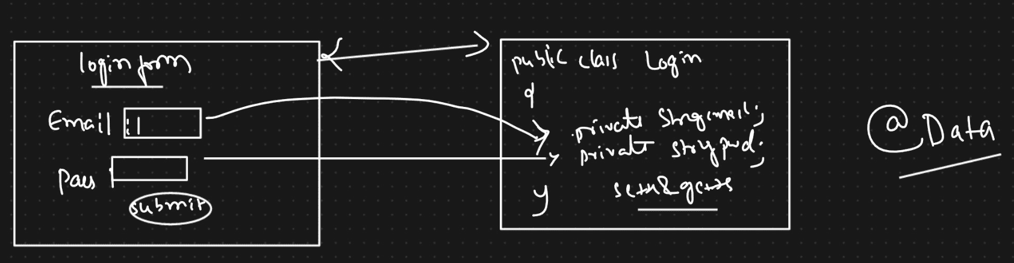

--> we need t o bind form with java class object
- > we must establish relations between form fields and java class variables for data binding
> To work with form, Spring MVC --> Form Tag library
form:form --> contains all other form tags

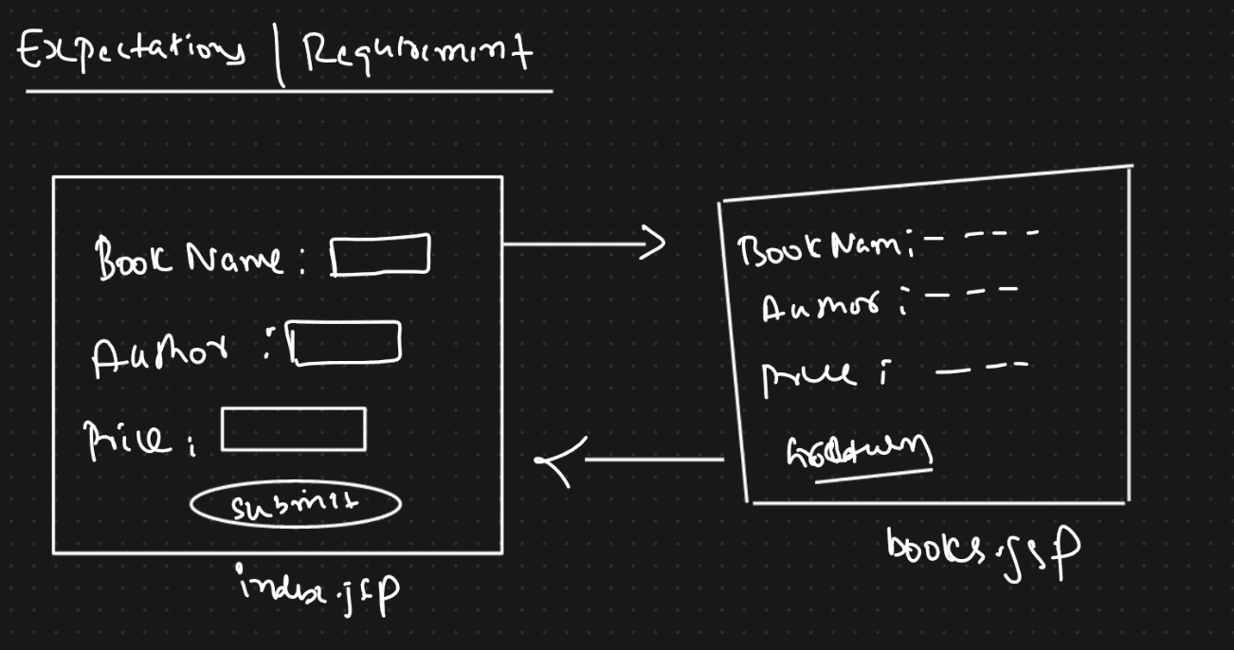
1) Create Spring boot application with dependencies listed below
a ) spring-boot-starter-web
b) tomcat-embed-jasper
c) devtools
d ) project Lombok
2) Configuration in application.properties file
a ) server port
b)view resolver
3 ) Create form binding class(To hold data)
4) Create Controller class with methods t o handle requests
5) Create presentation files
6) Run the application

173 SpringDataJPA using SpringBoot (CrudRepository and PagingAndSortingRepository)
Lombok api, eclipse debugging ===> session on monday from 7.30PMIST to 11.00PM IST
link will be sent to both the batches
Spring Data
===========
=> Spring data JPA
=> Spring data MongoDB
Before the arrival of Spring data module
========================================
SpringAPP ====Spring JDBC============> RDMB s/w or SQL DBS/W
(JDBCstyle)
SpringApp =====Spring ORM============> RDBMS s/w or SQL DBS/W
(OR-Mapping)
SpringApp ====MongoDB API + MongoDB Driver======>MongoDB S/W(NOSQL DBS/w)
SpringApp ====Casendra API + Casendra Driver======>Cassendra S/w(NOSQL DBS/w)
Note: Spring is not having any module to interact with NO SQL DBs/w before the
arrival of Spring Data module
Note: Before arrival of Spring data module there is no single unified mechanism to
talk both SQL and NoSQL DB s/w from Spring.
We need to use different types of SQL or NO-SQL DBS/W.
SpringData module provides abstraction on multiple technologies and frameworks to
simplify the interaction b/w both SQL and
NO SQLDBs/w in the unified model environment.
Important sub modules of spring data module
===========================================
a. Spring data JPA => provides abstraction on ORM S/w
b. Spring data JDBC => provides abstraction on JDBC technology.
c. Spring data MongoDB => provides abstraction on MongoDB api and etc....
Main Modules
============
a. Spring Data JPA => Spring Data Repository support for JPA
b. Spring Data MongoDB => Spring based, object document support and repositories
from MongoDB.
Limiation of SpringORM
======================
1. If we have 500 tables, then we need to have 500 DAO interfaces, followed by
500 implementation classes for all the interface
and in all the implementation class the CRUD operation would be a common
operation.
2. In the above approach, the logic of many operations would be duplicated
resulting in "boiler plate" code.
3. To resolve this problem Spring community had come up with a module called
SpringDATA which would generate redundant code
automatically through an Pre-Defined Repositories.Spring Data JPA code
====================
=> Just create Repository/DAO Interface extending Interface
PreDefined Repository
(different
types of repository interfaces are there)
(logic of many method prewritten)
=> If needed declare some custom methods by following coding conventions.
Advantages with SpringDataJPA
=============================
=> Now for 500 Db Tables, we just need to take 500 CustomRespository interfaces
having optional custom delare methods.
=> Implementation classes of CustomRespository interface will be generated
dynamically providing persistence logics for common
methods which are inherited from Pre-Defined Repository interface and also for
custom method declartion.
Note: All these operations are taken care by springdatajpa using InMemory
Proxy-classes.
Normal Java class
=================
.java =====> .class(HDD) ======> JVM loads the .class file(JVM memory RAM) ===>
execution class file(JVM Memory of RAM)
In memory java class
====================
Run the application ===> source code generation(JVM memory RAM) ===>
compilation(JVM memory of RAM)
===> JVM loads the .class file =====> execution of class file(JVM
memory of RAM)
Note:: Spring DataJPA uses ProxyDP to generate the implementation class of
programmer supplied DAO/Repository interface as
a InMemory Proxy class dynamically at the runtime.
While working with Spring DataJPA, the peristence layer just contains
DAO /Repository interface having just few
custom method declarations.
Spring Data JPA
=> It internally uses hibernate as ORM Framework
=> Strong knowledge of hibernate is required to understand.
=> While working with annotations we need to prefere the following order to build
Entity classes
a. JPA annotation
b. Java config annotations
c. hibernate specific annotations
d. Third party supplied annotations
Repositories============
1.Repository
2.CrudRepository
3.PagingAndSortingRepository
4.JpaRepository
ids:: 1,2,4,5 ===> deletion should be succesfull
ids:: 3,5,6 ===> problem in deletion
refer:: DAO-SpringDataJPA-CRUDRepository
PagingAndSortingRepository(I)
=> It is given to perform sorting of records and pagination.
=> Pagination will display huge amount of records page by page.
=> We can sort the records either in Ascending order or in Descending order
In Ascending order
a. special characters(*,?,-,...)
b. numbers(0-9)
c. upper case alphabets(A-Z)
d. lower case alphabets(a-z)
Iterable<T> findAll(Sort sort)
==============================
=> It performs sorting in ascending order or descending order based on the given
property(single/mulitple)
=> We need to specify the inputs to sort through Sort Object.
Page<T> findAll(Pageable pageable)
==================================
=> This method takes pageNo(0 based),pageSize as the input in the form of Pageable
object and returns the output as Page<T> obj
having requested pageRecords,pagesCount,currentnumbers,total records etc.....
total records => 20
page size => 5
pages => 4
pageNo => 0,1,2,3[Every page 5 records so totally 20 records]
======================================================================
total records => 20
page size => 5
pages => 3
pageNo => 0,1,2[Every page 5 records, autoamtically 3th page 16-20 records]
========================================================================
total records => 20
page size => 5
pages => 2
pageNo => 0,1[Every page 5 records,automatically 2nd page 11 to 15
records,autoamtically 3th page 16-20 records]
refer:: DAO-SpringDataJPA-PagingAndSortingRepository
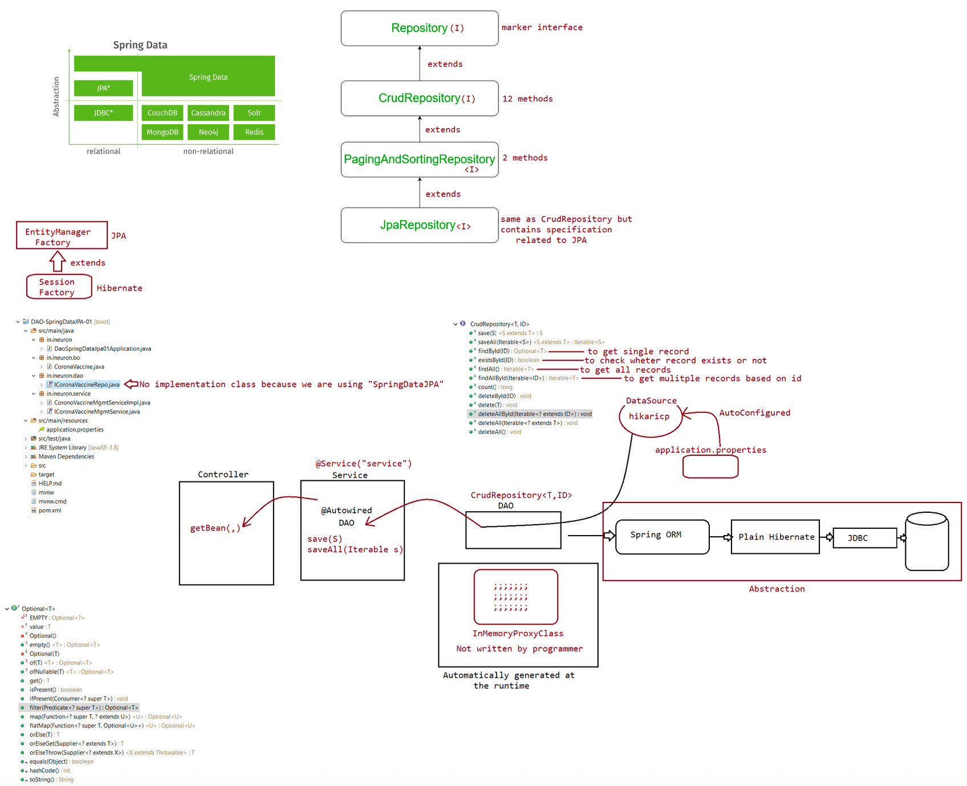
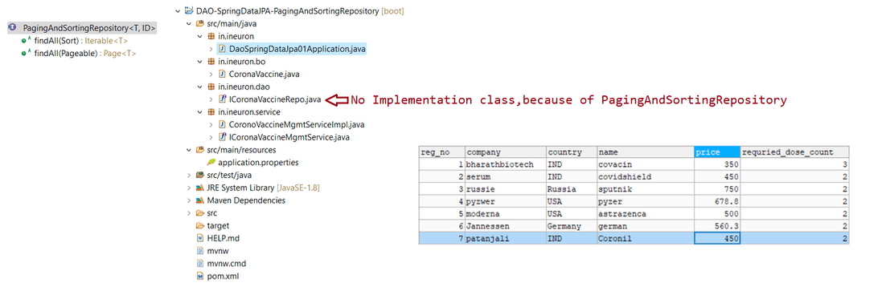

174 SpringDatajpa using JPA repository, findermethods and its usage, static project,dynamic projection, working with Date and time api, working with Storedprocedure...

LombokAPI,Eclipse Debugging => Session on 17th April,timing :: 7.30PM IST
link will be shared to both the batches
SpringMongoDB
Plz watch navinreddy sir youtube video of ====> https://www.youtube.com/watch?v=kYiLzIiHVY8
link::
Morning session[Enterprise java batch]
=======================================
Tuesday,Wednesday,Thursday ===> Timings :: 6.30AM IST to 9.00AM IST
topics pending: SpringBootMongoDB, Spring AOP,Spring Security,Spring Mail
JpaRepository(I)
===============
findAll(Example<S> example,Sort sort)
Example Object is a Container object holding Entity Object,It is just like
Optional<T>object.
application.properties
======================
spring.jpa.properties.hibernate.enable_lazy_load_no_trans=true //required while
working with getById(),getReferenceById(,)
When we use JpaRepository, we need to enable lazy loading through a special
property of hibernate as shown above.
What is the difference b/w deleteAllByIdInBatch(Iterable<ID> ids) of JpaRepository
and deleteAllById(Iterable<ID> ids) of CRUD Repository?
deleteAllByIdInBatch(Iterable<ID> ids) => generates single sql delete query having
in clause to delete the records,if id's not avaialble it
will not throw any
Exception.
deleteAllById(Iterable<ID> ids) => generates multiple sql delete query to
delete multiple records of the given ids,if any one of the
given id is not available
then it would throw Exception.
What is the difference b/w findAll() methods of different repositories?
findAll()=> JpaRepository => sorting available, no pagination,passing of
Example object,return type :: List<T>
findAll()=> CrudRepository => sorting not avalable,no pagination, no passing
of Example Object, return type :: Iterable<T>
findAll()=> PagingAndSortingRepository => sorting available, pagination
available, no passing of Example object ,return type :: Iterable<T>
Note:
save() => It comes from CrudRepository, we can perform both insert and update
operation,it this process to perform commit and rollback
operation, it takes the support of
TransactionManger(tx.commit(),tx.rollback()).
saveAndFlush() => It comess from JpaRepository, we can perform both insert andupdate operation,in this process it uses flush() to write the
changes to the database without any TransactionManger
support.
=> Prefer using CrudRepository and PagingAndSortingRepository becoz these
repositories are common repositories while working with
SpringData-JDBC,SpringData-JPA and SpringData-Mongodb,.....
Custom Persitence Operations in SpringDataJPA
=============================================
1. To Perform peristence operation with our choice conditions
2. To execute HQL,SQLqueries,NativeSQL Queries
3. To call StoredProcedures and To perform insertion of BLOB/CLOB
Mechanisms
==========
a. finder methods(only for select operation)
b. @Query methods(To execute HQL/JPQL,native sql select queries)
c. @Query + @Modifying Methods(To execute HQL/JPQL,native sql non-select queries)
finder methods
==============
=> These are custom abstract methods placed in our repository interface which will
be converted into select sql query.
=> It support both Entity select operation(all col values) and scalar select
operation(specific col values)[Projection]
=> We can prepare finder methods having one or more conditions with different
clauses like and,or,in,....
syntax:: public <Return Type>
findBy<propertyNames><conditions>(params...)
=> Implementation of finder methods takes place in the spring data jpa generated
InMemoryProxy class.
=> we can take finder method without any condition,then by default condition that
will be applied is "equals(=)" on the given property/column.
@Entity
public class CoronaVaccine implements Serializable {
private static final long serialVersionUID = 1L;
@Id
@GeneratedValue(strategy = GenerationType.IDENTITY)
private Long regNo;
private String name;
private String company;
private String country;
private Double price;
private Integer requriedDoseCount;
}
public interface ICoronaVaccineRepo extends JpaRepository<CoronaVaccine, Long> {
public List<CornoVaccine> findByCompany(String company)
}
eg::DAO-SpringDataJPA-CustomQueryApp
Static Projection
=================
In case of Static Projection,we have 2 Proxy classesa. ResultView(I) =======> To hold the Result[column names] returned by the
Query
b. ICoronaVaccineRepo(I) ===> To Represent a DAO Repository(take the help of
JpaRepository)
In case of Dynamic Projection
=> here we can get varying specific single column or mulitple columns from
dbtable using the support of finder methods.
=> For this support we take multiple types of interface having hierarchy as show
below
interface View{
}
interface ResultView1 extends View{
public String getName();
public String getCompany();
}
interface ResultView2 extends View{
public Long getRegNo();
public Double getPrice();
public String getCountry();
}
interface ResultView3 extends ResultView1{
public String getPrice();
}
DaoLayer
========
public interface ICoronaVaccineRepo extends JpaRepository<CoronaVaccine, Long> {
public <T extends View> List<T> findByCompanyOrderByCompanyDesc(String
company, Class<T> clazz);
} |
|
Controlling Type of 'T' which is returned as List<T>
RunTime supplied class
Executing Storedprocedure
=========================
USE `enterprisejavabatch`$$
DROP PROCEDURE IF EXISTS `P_GET_PRODUCT_BY_NAME`$$
CREATE DEFINER=`root`@`localhost` PROCEDURE `P_GET_PRODUCT_BY_NAME`(IN name1
VARCHAR(20), IN name2 VARCHAR(20))
BEGIN
SELECT pid,pname,price,qty FROM products WHERE pname IN (name1,name2);
END$$
DELIMITER ;
refer:: DAO-SpringDataJPA-StoredProcedureApp
Working with Date and Time Operation
====================================JDK8 features(Jodha API)
LocalDateTime,LocalDate,LocalTime
refer:: DAO-SpringDataJPA-DateTimeInsertionAPI

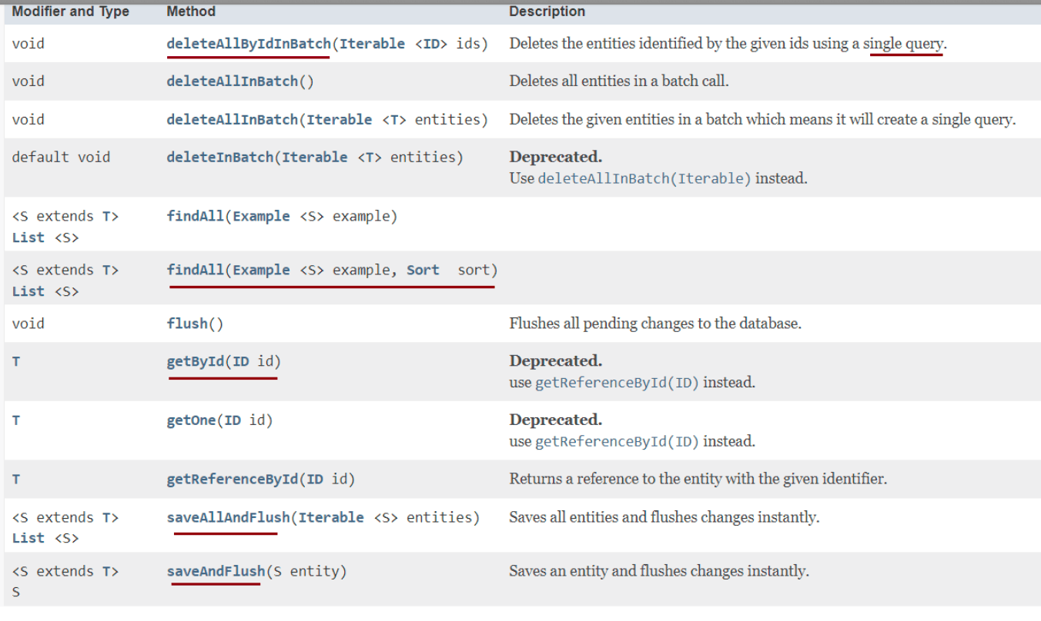
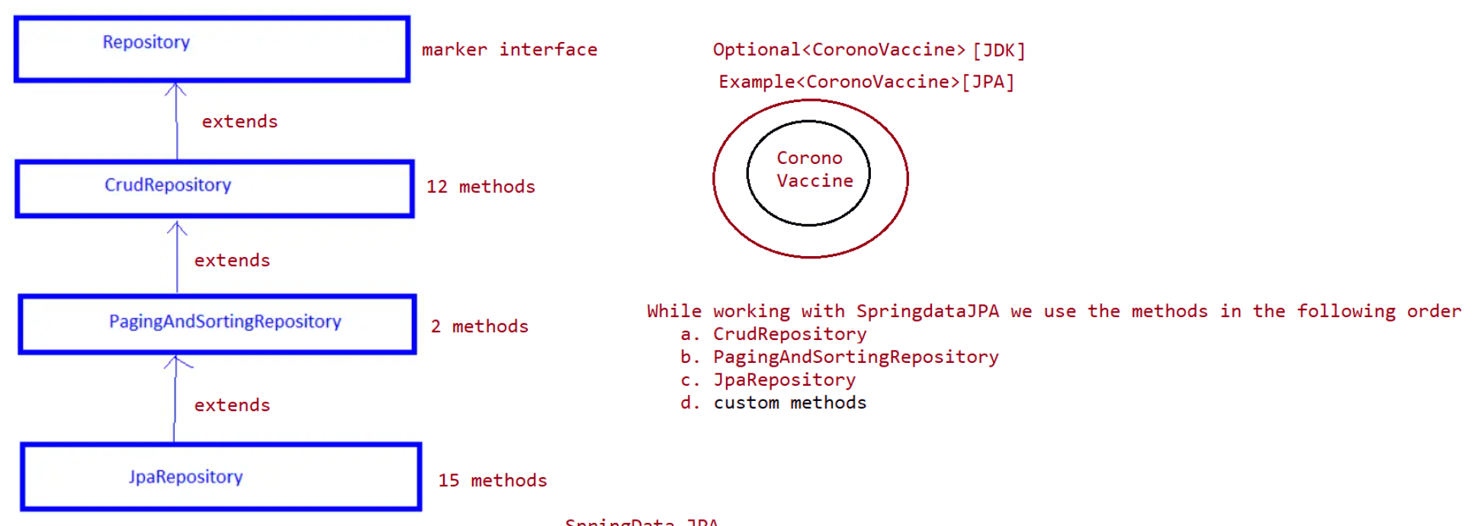
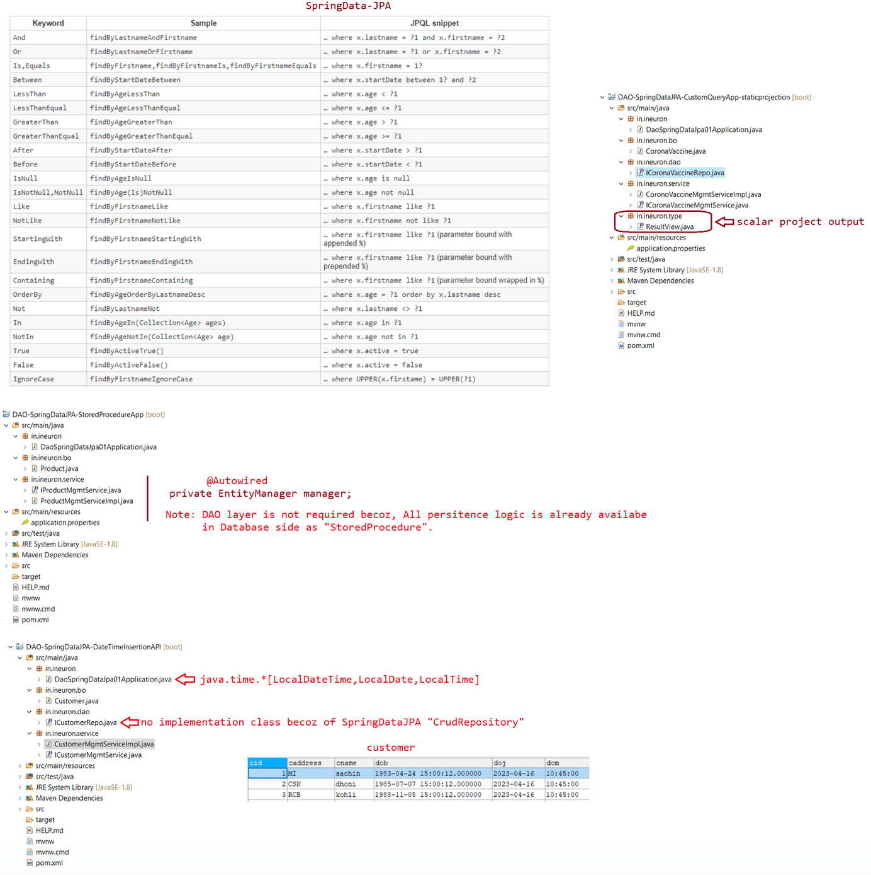

175 lombok api, usage of lombok api in hibernate, integration of hiberante +log4j using maven

Java Bean is a java class that is developed with the following standarads
a. class must be public
b. Recomended to implement Serializable interface
c. Bean property variable should be private and non-static
d. Every bean property should have one pair of Setter and getter method
e. It should have zero parameter constructor directly or indirectly
There are 3 types of java beans
a. VO class(Value Object) => To hold user inputs
b. DTO(Data Transfer Object) => To carry the data from one layer to another
layer in a project
c. BO(Buisness Object) => To hold persistable object/persistable data.
A well designed java class should contain
a. Overloaded constructor
b. toString()
c. equals() method
d. hashcode() method
e. setters and getters(optional)
Before Lombok API
=================
=> We need to make our java class well designed java class by the adding the above
said methods manually and
we should manually increase or decrease the setter methods and getter methods
based on no of properties we
are adding/removing.
With Lombok API
===============
=> All the above things will be taken care and generated automatically.
=> Lombok API is also called as "Project Lombok" which generates the following
boiler plate of java code
a. constructors
b. setters and getters
c. toString()
d. equals()
e. hashcode() ....
=> It is an open source api.
=> It must be configured with IDE's to make IDE's using lombok api to generate the
common boiler plate code.
=> It supplies bunch of annotations for generating the common code
Annotations::
@Setter,@Getter,@AllArgsConstructor,@NoArgsConstructor,@RequiredArgsConstructor,@To
String,@EqualsAndHashCode
@Data(It is mix of multiple annotations) etc,....
Steps to Configure Lombok API with eclipse IDE
==============================================
step1: Download lombok-<ver>.jar from mvnrepository.com
step2: make sure eclipse/sts ide is downloaded
step3: create proejct in eclipse ide or sts ide by adding lombok-ver.jar file to
the build path
step4: launch lombok api by clicking on lombok-ver.jar and specify the
eclipseide/sts ide installation folder
click on install/update button, click on quit installerstep5: restart eclipse ide
step6: Add one java bean class to project of eclipse ide/sts ide by lombok api
annotation and observe whether code is generated or not.
Note: lombok api annotations make java compiler to generate certain code dynamicaly
in the .class file
java compiler is having the ability to add code dynamically to the .class
file though the instructions are not there in .java like
default consturctor generation makes java.lang.Object as default super class
and etc.
Note: Lombok Retention level is source,it means these annotations will not be
recorded in the .class file, but becoz of lombok
annotations instructions the code gets generated by javac compiler like
setters,getters,toString() etc will be
recorded to .class file.
@Getter,@Setter
=> These annotations are applied at the class level, generates getter and setter
for all field/properties.
=> If these are applied at the field level, generates getters and setters only for
specific field/properties.
Eg#1.
@Getter
@Setter
class Student{
private Integer sid;
private String sname;
private Integer sage;
}
Student.class
============
class Student{
private Integer sid;
private String sname;
private Integer sage;
setXXX(),getXXXX(),Student(){}
}
Eg#2.
class Student{
private Integer sid;
private String sname;
@Getter
@Setter
private Integer sage;
}
Student.class
============class Student{
private Integer sid;
private String sname;
private Integer sage;
setSage(),getSage(),Student(){}
}
@ToString()
==========
=>It makes the javac to generate /override toString() having the logic to display
the object data.
=>It is applicable only on the top of the class(@Target(ElementType.TYPE))
eg#1.
@ToString
public class Employee {
private Integer sid;
private String sname;
private Integer sage;
private String saddress;
}
Employee.class
==============
public class Employee {
private Integer sid;
private String sname;
private Integer sage;
private String saddress;
Employee(){}
public String toString(){
prints the object data.
}
}
What is the use of toString()?
=> It is useful to display the object data in string format
=> If we don't override this method in our class ,then java class toString()
executes and this method gives
<fullyqualifiedclassname>@hexadecimal notation of hashCode>.
public String toString() {
return getClass().getName() + "@" +
Integer.toHexString(hashCode());
}
can we customize the logics generated by lombok api?
Ans. not possible.
What will happen if we try to override toString() explicitly along with lombok api
code?
=> @ToString of lombok api will not give instruction to generate toString()
becoz same method is already available in .java file.
(warning will come on top of @ToString)
same is applicable for @Getter,@Setter.
EqualsAndHashCode
==================> Generates equals() and hashcode() by giving instruction to java compiler(javac)
=> It is applicable at class level(@Target(ElementType.TYPE))
What is HashCode?
=> It is the unique identity number given by jvm for every object.. and we can get
by calling hashcode() method.
System.out.println(c1.hashCode() + " " + c2.hashCode());
Can 2 objects have same hashcode?
=> If hashcode is given by jvm then it is not possible,because hashcode is
generated based on hashing algorithm.
=> If we overide hashcode() method our code, generally it generates the hashcode
based on the state of the object
therefore if 2objects are having same state, then we get same hashcode for both
objects.
eg::
@EqualsAndHashCode
@AllArgsConstructor
@ToString
public class Employee {
private Integer sid;
private String sname;
private Integer sage;
private String saddress;
}
public class TestApp {
public static void main(String[] args) {
Employee e1 = new Employee(10, "sachin", 49, "MI");
Employee e2 = new Employee(10, "sachin", 49, "MI");
System.out.println(e1.hashCode()+"==="+e2.hashCode());// 123456 ====
123456 (because we use @EqualsAndHashCode,state of object is same)
System.out.println(System.identityHashCode(e1));
System.out.println(System.identityHashCode(e2));
}
}
Can object have 2 hashCode?
Ans. yes possible, one hashcode is based on the state of the object and the other
one is internally generated by jvm.
To get the hashcode generated by jvm we use a method called
"System.identityHashCode(obj)".
What is the use of equals() method?
=> It is given to compare the state of 2 objects,it internally use hashcode
supports also.
=> If we override equals() in our class, then it will compare the state of the
object, otherwise it will execute the object class equals()
which will compare the reference of the object.
public boolean equals(Object obj) {
return (this == obj);
}
what is the difference b/w == and equals()?
=> Both will compare the reference if both are not overriden in our class.
=> If equals() overriden,then it compares the state of the object, then ==
operator will compare the reference.eg#1.
@EqualsAndHashCode
@AllArgsConstructor
@ToString
public class Employee {
private Integer sid;
private String sname;
private Integer sage;
private String saddress;
}
public class TestApp {
public static void main(String[] args) {
Employee e1 = new Employee(10, "sachin", 49, "MI");
Employee e2 = new Employee(10, "sachin", 49, "MI");
System.out.println(e1==e2);//false[compares the reference maintained by
jvm internally for objects]
System.out.println(e1.equals(e2));//true [compares the state of the
object becoz overriding equals() in our class]
}
}
Constructor Creation
====================
@NoArgsConstructor => Generates Zero param constructor
@AllArgsConstructor => Generates parameterized constructor having all
properties/fields as fields.
If no properties in our class then Zero param
constructor.
eg#1.
@AllArgsConstructor
@NoArgsConstructor
public class Employee {
private Integer sid;
private String sname;
private Integer sage;
private String saddress;
}
public class Employee {
private Integer sid;
private String sname;
private Integer sage;
private String saddress;
public Employee(Integer sid,String sname,Integer sage, String saddress){
;;;;
;;;;
;;;;
}
public Employee(){}
}
eg#2.
@AllArgsConstructor
@NoArgsConstructor
public class Employee {}
@AllArgsConstructor
@NoArgsConstructor
public class Employee {
//Error(becoz constructor can't be duplicated)
public Employee(){}
public Employee(){}
}
Note:Only 0-param constructor generated by compiler is called "Default
constructor".
If we write 0-param constructor and if it is generated by lombok then it is
should not be called as "Default constructor".
eg: int a ; //instance level => default value is "0"
int a =0;//instance level => This is not a default value it
is initialized to zero.
Can we overload/override Constructor?
Ans. We can't override constructor, we can just overload constructor.
eg::
@NoArgsConstructor
public class Customer{
public Customer(){
}
}
public class Customer{
//Error(becoz constructor can't be duplicated)
public Customer(){}
public Customer(){}
}
@RequiredArgsConstructor
=======================
=> Allows to generate parameterized constructor involving our choice
properties/fields.
=> The properties that we need to involve should be annotated with @NonNull
annoatation.
=> If no properties are annotated with @NonNull then it will give Zero param
constructor.
eg#1.
@RequiredArgsConstructor
public class Employee {
private Integer sid;
private String sname;
private Integer sage;
private String saddress;
}
public class Employee {
private Integer sid;
private String sname;private Integer sage;
private String saddress;
public Employee(){}
}
eg#2.
@NoArgsConstructor
@RequiredArgsConstructor
public class Employee {
private Integer sid;
private String sname;
private Integer sage;
private String saddress;
}
public class Employee {
private Integer sid;
private String sname;
private Integer sage;
private String saddress;
public Employee(){}
public Employee(){}
}
eg#3.
@RequiredArgsConstructor
public class Employee {
@NonNull
private Integer sid;
@NonNull
private String sname;
private Integer sage;
private String saddress;
}
public class Employee{
@NonNull
private Integer sid;
@NonNull
private String sname;
private Integer sage;
private String saddress;
public Employee(Integer sid,String sname){.......}
}
eg#4.
@RequiredArgsConstructor
@AllArgsConstructor
@NoArgsConstructor
public class Employee {
@NonNullprivate Integer sid;
@NonNull
private String sname;
private Integer sage;
private String saddress;
}
public class Employee {
@NonNull
private Integer sid;
@NonNull
private String sname;
private Integer sage;
private String saddress;
public Employee(){}
public Employee(Integer sid,String sname,Integer sage,String saddress){}
public Employee(Integer sid,String sname){...}
}
Note: We can take constructor as private,protected,public. To get them through
lombok api we can use "access" attribute of
@XxxxArgsConstructor as shown below.
@AllArgsConstructor(access = AccessLevel.PRIVATE)
@RequiredArgsConstructor(access = AccessLevel.PROTECTED)
@NoArgsConstructor(access = AccessLevel.PUBLIC)
public class Employee {
;;;;;;
}
Note::
=> we cannot generate constructor with var args
=> we cannot generate multiple our choice parameterized constructor at a time like
1param,2param with 3param at a time.
@Data
=====
=> It is a Combination of
@Getter,@Setter,@EqualsAndHashCode,@ToString,@RequiredArgsConstructor.
@Data
public class Employee {
@NonNull
private Integer sid;
@NonNull
private String sname;
@NonNull
private Integer sage;
private String saddress;
}
public class Employee{
Employee(Integer, String, Integer)canEqual(Object)
equals(Object)
getSaddress()
getSage()
getSid()
getSname()
hashCode()
setSaddress(String)
setSage(Integer)
setSid(Integer)
setSname(String)
toString()
}
@Data
@AllArgsConstructor
public class Employee {
@NonNull
private Integer sid;
@NonNull
private String sname;
@NonNull
private Integer sage;
private String saddress;
}
Note: @RequiredArgsConstructor of @Data works only when
@AllArgsConstructor,@NoArgsConstructor is not placed on top of the class.
If u still need the effect of @RequiredArgsConstructor then place it
explicitly.
eg#2.
@Data
@AllArgsConstructor
public class Employee {
@NonNull
private Integer sid;
@NonNull
private String sname;
@NonNull
private Integer sage;
private String saddress;
}
public class Employee{
Employee(Integer, String, Integer, String)
canEqual(Object)
equals(Object)
getSaddress()
getSage()getSid()
getSname()
hashCode()
setSaddress(String)
setSage(Integer)
setSid(Integer)
setSname(String)
toString()
}
eg#3.
@Data
@NoArgsConstructor
@AllArgsConstructor
@RequiredArgsConstructor
public class Employee {
@NonNull
private Integer sid;
@NonNull
private String sname;
@NonNull
private Integer sage;
private String saddress;
}
public class Employee{
Employee()
Employee(Integer, String, Integer, String)
Employee(Integer, String, Integer)
canEqual(Object)
equals(Object)
getSaddress()
getSage()
getSid()
getSname()
hashCode()
setSaddress(String)
setSage(Integer)
setSid(Integer)
setSname(String)
toString()
}

176 SpringDataJPA(working with LOB's, Working with HQL,Working with NativeQuery,Working with Projections)

Note:: Plz watch navinreddy sir youtube video of ====> SpringMongoDB
https://www.youtube.com/watch?v=kYiLzIiHVY8
link::
LOB
a.BLOB(Binary Large Object ===> audio file,video file, image file,pdf and etc)
b.CLOb(Character Large Object ===> Text file,Rich Text file,CSV file and etc)
To work with LOB's we need to map entity class to DBTable using annotations
BLOB => Take a byte[] property in Entity class and mark the annotation called
@Lob
CLOB => Take a char[] property in Entity class and mark the annotation called
@Lob
The boolean property data(true/false) of Entity class object will be stored in
db table as bit column which holds the
value 0 or 1,
MarriageSeeker.java
===================
package in.ineuron.bo;
import java.io.Serializable;
import java.time.LocalDateTime;
import javax.persistence.Entity;
import javax.persistence.GeneratedValue;
import javax.persistence.GenerationType;
import javax.persistence.Id;
import javax.persistence.Lob;
import lombok.Data;
import lombok.NoArgsConstructor;
import lombok.NonNull;
import lombok.RequiredArgsConstructor;
@Entity
@Data
@NoArgsConstructor
@RequiredArgsConstructor
public class MarriageSeeker implements Serializable {
private static final long serialVersionUID = 1L;
@Id
@GeneratedValue(strategy = GenerationType.IDENTITY)
private Long id;
@NonNull
private String name;
@NonNull
private String address;
@Lob
@NonNull
private byte[] photo;@NonNull
private LocalDateTime dob;
@Lob
@NonNull
private char[] bioData;
@NonNull
private Boolean indian;
}
Code to read the data into byte[] and char[]
============================================
InputStream inputStream = new FileInputStream(photoPath);
byte[] photoData = new byte[inputStream.available()];
inputStream.read(photoData);
File file = new File(bioData);
Reader reader = new FileReader(file);
char[] bioDataContent = new char[(int) file.length()];
reader.read(bioDataContent);
Code to write the data from byte[] and char[]
=============================================
OutputStream os = new FileOutputStream("retrieve_image.jpg");
os.write(seeker.getPhoto());
os.flush();
Writer writer = new FileWriter("retrive_biodata.txt");
writer.write(seeker.getBioData());
writer.flush();
Working with @Query methods
===========================
On the top of custom methods declared in our repository interface, we need to add
@Query annotation either having JPQL/HQL/
Native SQL Query.
Methods can have flexible signature and no need of following any naming
conventions.
Syntax
======
@Query("HQL/JPQL/nativesqlqueries")
<return_type><method_name><params....)
Note:
SQL> SELECT * FROM CORONA_VACCINE;
HQL> FROM in.ineuron.bo.CoronaVaccine
SQL> UPDATE CORONA_VACCINE SET price = price + ? where company = ?
HQL> UPDATE in.ineuron.bo.CoronaVaccine SET price = price+:addOnPrice WHERE company
=:manufacture
SQL> SELECT REGNO,COMPANY,NAME FROM CORONA_VACCINE WHERE COMPANY IN (?,?)HQL> SELECT regNo,company,name FROM in.ineuron.bo.CoronaVaccine WHERE company
IN(:comp1,:comp2)
HQL> SELECT cv.regNo,cv.company,cv.name FROM in.ineuron.bo.CoronaVaccine as cv
WHERE cv.company IN(:comp1,:comp2)
Note:
@Query("FROM CoronaVaccine WHERE COMPANY = ?1")
@Query("From in.ineuron.bo.CoronaVaccine WHERE company=:vendor")
public List<CoronaVaccine> searchVaccinesByCompany(String vendor);
The method parameter values will be bounded with named param values automatically
if there names are matching, otherwise we need
to use @Param explicitly.
eg::
@Query("FROM CoronaVaccine WHERE company=:comp")
public List<CoronaVaccine> searchVaccinesByCompany(@Param("comp")String vendor);
eg::
public interface ICoronaVaccineRepo extends JpaRepository<CoronaVaccine, Long> {
@Query("FROM CoronaVaccine WHERE company=:comp")
public List<CoronaVaccine> searchVaccinesByCompany(@Param("comp")String
vendor);
@Query("FROM CoronaVaccine WHERE company IN(:comp1,:comp2)")
public List<CoronaVaccine> searchVaccinesByComapnies(String comp1,String
comp2);
@Query("SELECT name FROM CoronaVaccine WHERE price BETWEEN :min AND :max")
public List<String> searchVaccinesByPriceRange(double min,double max);
@Query("SELECT name,company,price from CoronaVaccine WHERE name
IN(:name1,:name2)")
public List<Object[]> searchVaccinesByName(String name1,String name2);
}
1. service.fetchVaccinesByCompany("bharathbiotech").forEach(System.out::println);
2. service.fetchVaccinesByCompanies("bharathbiotech",
"serum").forEach(System.out::println);
System.out.println();
3. List<Object[]> names = service.fetchVaccinesByName("covidshield", "covacin");
for (Object[] objects : names) {
for (Object obj : objects) {
System.out.print(obj + " ");
}
System.out.println();
}
System.out.println();
4. List<String> vaccineNames = service.fetchVaccinesByPriceRange(250.0, 750.0);
System.out.println(vaccineNames);refer:: DAO-SpringDataJPA-@QueryMethods_App

177 Eclipse Debugging using IDE Debugger, Debugging for standalone application,Spring projects and hibernate projects

19/04/2023 :: 7AM to 9.30AM (SpringBoot Mongodb)
20/04/2023 :: SpringAOP,Spring Mail
21/04/2023 :: Spring Mail,SpringSecurity
================================================
Weekend :: SpringRest(saturday and sunday) :: 9.00AM to 2.00PM
Microservices
=============
24th to 30th(Full Microservices)
Eclipse Debugging
=================
Debugging is a process of getting step by step by execution in an application to
find out problem/bugs and fix them as needed.
Terminologies associated with Debugging
a. Bugs => Problem/defect/mistake in the app/program/project[some
abnormality in the application execution]
Debug = > De + bug [Rectifiying the bug by identifying and Analyzing the bug]
The tools or programm or software that can be used for debugging is called
"Debugger"/Debugging tool
To debug java code we have two tools
a. JDB(Supplied by jdk tools with jdk installation)
=> available inside <java_home>\bin directory as jdb.exe
=> it is CUI tool and not so popular(Not industry standard)
b. IDE supplied Debugger
=> Eclipse/Intelij/EclipseLink and etc ... IDE supplied Debuggers
=> These are GUI and they are user friendly
=> These are industry standard
Where Debugging is required in the company?
a. To find,analyze and fix logic problems/errors
b. if unit testing is failed, then also we use debugging to fix the problems[Run
Junit in Debugging mode]
c. After joining in the company that to existing project then the programmer
performs debugging process to know flow in the project.
d. If the project is in production then the bugs received will be fixed only
after seeing log files[log messages] and after
performing debugging.
refer:: Debuggingimage_01
Debugging in eclipse
====================
=> Run the apps in Debug mode
=> Change eclipse mode to debug perspective
=> use various debugging operations/shortcuts to see the code flow to find out
the problem and fix the problem.
breakpoint:: It is the point in the App/Project/code/program from where the
debugging process would start.
Till the breakpoint code executes normally.
From the breakpoint control comes to programmer to see the code flow
as needed.
Two types of Breakpoint=======================
1. Method Breakpoint :: Give at method name of method defnition
2. Line Breakpoint :: Given inside the method defnitions where logics are
available.
DemoApp.java
============
package in.ineuron.test;
import java.util.Scanner;
public class DemoApp {
public void sayHello(String name) {
System.out.println("DemoApp.sayHello()");
for (int i = 1; i <= 10; i++)
System.out.println(name + " ");
System.out.println("End of sayHello()");
Scanner scanner = new Scanner(System.in);
System.out.print("Enter the message:: ");
String msg = scanner.next();
displayMsg(msg);
}
public void displayMsg(String msg) {
System.out.println("DemoApp.displayMsg() :: "+msg);
System.out.println("DemoApp.displayMsg() :: "+msg);
printNumber(10);
}
public void printNumber(int n) {
System.out.println("DemoApp.printNumber()");
for(int i = 1;i<=n;i++)
System.out.println(i);
System.out.println("end");
}
public int add(int a, int b) {
System.out.println("DemoApp.add()");
return a + b;
}
public int sub(int a, int b) {
System.out.println("DemoApp.sub()");
return a - b;
}
public static void main(String[] args) {
DemoApp app = new DemoApp();
app.sayHello("sachin");
app.add(10, 20);
app.add(30, 20);
}
}eclipse shortcut
================
ctrl+shift+B :: To toggle break(To enable or disable method/line break point)
F6 :: Step Over(line by line execution)
F5 :: Step into(executing the method body)
F7 :: Get the control back to caller
F8 :: Getting the control to move into another breakpoint(if it is the last
break point then program would be terminated)
drop to frame :: re-run back to the program[Takes the control to be the begining
of the method defnition whethere breakpoint is
available or not.]
Ctrl+R:: Take the cursor to that line [keep the breakpoint==> select any line
then cursor will go that line]
Ctrl+F5:: To step into selection[skipping the certain logic then moving into
specific one]
Working with StepFilter
======================
=> It allows certain packages not to participate in debugging, It is useful
especially if you are not interested in getting into details of
predefined classes and the methods like System.out.println().
Step1: Add the packages which should not participate in debugging process
window => prefereces =>java ====> Debugging => stepfiltering =>Add
packages(which should not participate)
Step2: Make sure step filter is in active mode
Step3: Debug the java application and press f5 button for clases and methods of the
above packages ,but it will not step into method defnition
Note:: By keeping mouse over variable or parameter of the debugging mode method
defnition we can watch value changes that are taking the
place in the application execution.
=> we can use variable window,expression window to see the value changes.
=> expression window is useful to given current inputs for another formula of
buisness logic to check the results.
=> Breakpoints window give list of breakpoints.
=> Show we can enable or disable them as needed.
=> we can add new breakpoints in the debugging mode of the application(dynamically
during the execution).
Standalone layered application components
=========================================
controller =====> service =======> DAO =====> Database
=> It is possible to add break points not only programmer developed user defined
classes.
=> It is possible in predefined classes that are internally used by user defined
classes
like HttpServlet,GenericServlet,System,DispatcherServlet,.....
=> While working with maven/gradle build tools we get built in java decompiler,
there is no need of arranging
decompilers seperately.
To see source code :: F3
To open details of current class/interface/enum including hierarchy ::
F4
=> In the middle of debugging also we can add/remove new break points dynamicallyeg:: Hibernate-DebuggingMode
IOC-RealTimeDependancyInjection
Debugging on WebApplication(Server level debugging)
===================================================
Instead of Run as Server,we need to choose Debug as server
code insde servlet
=================
public void doxXXXX(request,response){
PrintWriter out = response.getWriter();
out.println("<b>Today date is :: "+new java.util.Date()+"</b>");
for(int i =0;i<=10;i++)
out.println("<b>sachin&nbsp&nbsp"+i+"</b>");
out.println("end of doxXXXX()");
}
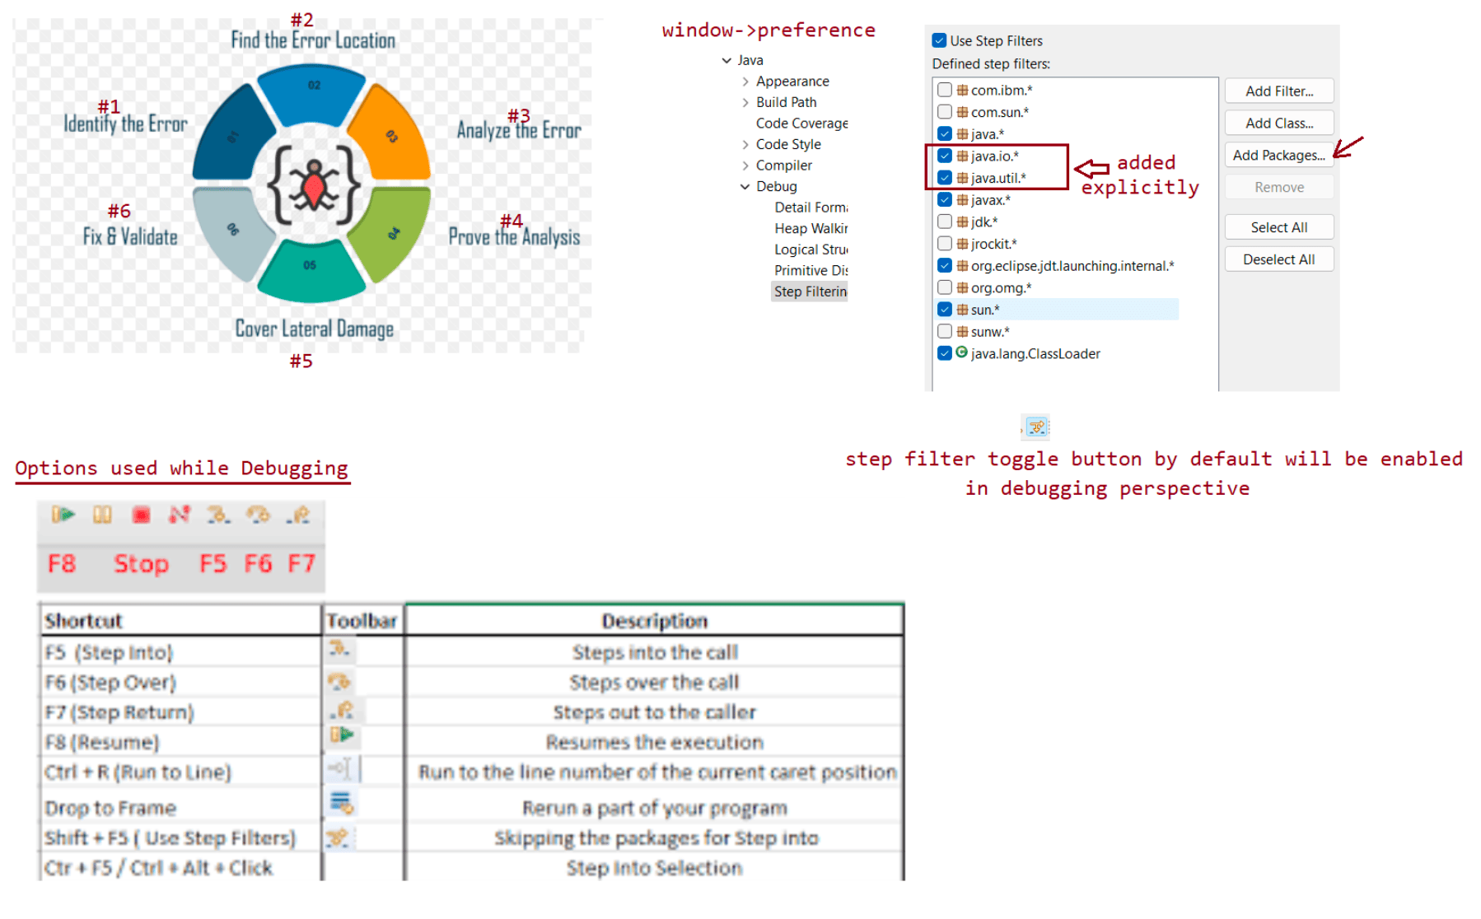

178 MongoDB installation, difference b w sql and nosql, working with crud operations of mongodb

Evening session :: Spring MVC(revision + remaining concepts + CRM project)
Tommo moring sesion :: Spring MongoDB(crud operations project)
On Saturday/Sunday ::SpringRest(9.00AM to 2.00PM)
From monday onwards ::Microservices(2 sessions per day[morning/evening]])[videos
will be uploaded]
SpringData MongoDB
==================
=> Spring data provides unified model to work with both SQL and NoSQL DB s/ws.
=> SQL DB s/w are oracle, postgresql,mysql and etc(DB tables based)
=> NoSQL Dbs/w are MongoDB,Cassendra,Couchbase,neo4j etc...(key-value
based,document based,graph based etc...)
=> If data is having fixed format and schema then we need to go SQL DB/sw.
=> If data is dynamically growing and no fixed format then go for NoSQL DB/sw.
Difference b/w SQL and NoSQL
============================
refer:: 19_04_2023_SpringBoot_mongodb_images
MongoDB
=======
=> It is document-based NOSQL DB s/w.
=> It internally maintains the data in the form of JSON Documents
JSON :: Java Script Object Notation
eg#1.
=>{
"Name": "sachin",
"address": {
"city": "Bandra",
"country" : "IND",
"State" : "Mumbai"
}
"PhoneNumbers": ["111-222-333","999-888-777-66"]
}
eg#2.
{
"emp_details":[
{
"emp_name":"sachin",
"email": "sachin@mi.com",
"job_profile": "batsman"
},
{
"emp_name":"dravid",
"email": "dravid@rcb.com",
"job_profile": "keeper"
},
{
"emp_name":"dhoni",
"email": "dhonin@csk.com",
"job_profile": "captain"
}
]
}MongoDB software installation
=============================
MongoDB download
link:: https://fastdl.mongodb.org/windows/mongodb-windows-x86_64-6.0.5-
signed.msi
select windows => select msi -> download
Install the setup file just like normal software(double click install)
Installation video link :: https://www.youtube.com/watch?
v=1y5sAnn0ans&ab_channel=CSCORNERSunitaRai
MongoDB port no :: 27017
Note: we have multiple mongodb gui tools or clients s/w like compass,robot3t etc...
To start mongodb software:: C:\Program Files\MongoDB\Server\4.4\bin\mongo.exe
SQL Terminologies
=================
Physical db software(like oracle,mysql)
|---> Logical db (SID)
|=> db tables(rows and columns)
=> Db table maintains records in the form of rows and columns
NoSQL Terminologies
==================
Physical DB software(like MongoDB)
|=> Logical DB1
|=> Collection1(document1,document2,....)[JSON]
Difference b/w SQL and No SQL
=============================
Table <======> Collection
Record <======> Document
MongoDB shell commands
=====================
1. add <mongodb_home>\bin folder to path environment variable
path :: C:\Program Files\MongoDB\Server\4.4\bin
2. open mongodb shell using mongo.exe file from command prompt of any location
cmd> mongo
3. To list all logical DBs
cmd> show dbs
MYDB 0.000GB
admin 0.000GB
config 0.000GB
local 0.000GB
4. To create a new logical DB
cmd> use fsDB
switched to db fsDB
Note:: untill u add a collection to logical db, the newly created logical db will
not appear in the list of logical dbs.
5. To Create a collection with one documentcmd> db.customer.insertOne({cno:7,cname:"dhoni",cadd:"CSK",avg:53})
cmd> db.customer.insertOne({cno:10,cname:"sachin",cadd:"mi",avg:54.5})
cmd> db.customer.insertOne({cno:18,cname:"kohli",cadd:"RCB",avg:54})
cmd> db.customer.insertOne({cno:63,cname:'SKY',cadd:'mi',avg:45.0})
6. To list out documents of the collection
cmd> > db.customer.find().pretty()
{
"_id" : ObjectId("643f5667caab5d65806450fc"),
"cno" : 10,
"cname" : "sachin",
"cadd" : "mi",
"avg" : 54.5
}
{
"_id" : ObjectId("643f56c8caab5d65806450fd"),
"cno" : 7,
"cname" : "dhoni",
"cadd" : "CSK",
"avg" : 53
}
{
"_id" : ObjectId("643f56d8caab5d65806450fe"),
"cno" : 18,
"cname" : "kohli",
"cadd" : "RCB",
"avg" : 54
}
7. To insert many documents at once into collection
> db.customer.insertMany([{cno:19,cname:"dravid",cadd:"RCB"},
{cno:45,cname:"rohith"}])
{
"acknowledged" : true,
"insertedIds" : [
ObjectId("643f597ccaab5d65806450ff"),
ObjectId("643f597ccaab5d6580645100")
]
}
8. To display the documents in a pretty fashion
> db.customer.find().pretty()
{
"_id" : ObjectId("643f5667caab5d65806450fc"),
"cno" : 10,
"cname" : "sachin",
"cadd" : "mi",
"avg" : 54.5
}
{
"_id" : ObjectId("643f56c8caab5d65806450fd"),
"cno" : 7,
"cname" : "dhoni",
"cadd" : "CSK",
"avg" : 53
}
{
"_id" : ObjectId("643f56d8caab5d65806450fe"),
"cno" : 18,"cname" : "kohli",
"cadd" : "RCB",
"avg" : 54
}
{
"_id" : ObjectId("643f597ccaab5d65806450ff"),
"cno" : 19,
"cname" : "dravid",
"cadd" : "RCB"
}
{
"_id" : ObjectId("643f597ccaab5d6580645100"),
"cno" : 45,
"cname" : "rohith"
}
Note:: https://www.mongodb.com/docs/manual/introduction/
9. Inserting document to a collection with array values
> db.customer.insertOne({cno:9,cname:'lara',mobileNo:
[9997776655,676676554]})
{
"acknowledged" : true,
"insertedId" : ObjectId("643f5bc7caab5d6580645101")
}
> db.customer.find().pretty()
{
"_id" : ObjectId("643f5667caab5d65806450fc"),
"cno" : 10,
"cname" : "sachin",
"cadd" : "mi",
"avg" : 54.5
}
{
"_id" : ObjectId("643f56c8caab5d65806450fd"),
"cno" : 7,
"cname" : "dhoni",
"cadd" : "CSK",
"avg" : 53
}
{
"_id" : ObjectId("643f56d8caab5d65806450fe"),
"cno" : 18,
"cname" : "kohli",
"cadd" : "RCB",
"avg" : 54
}
{
"_id" : ObjectId("643f597ccaab5d65806450ff"),
"cno" : 19,
"cname" : "dravid",
"cadd" : "RCB"
}
{
"_id" : ObjectId("643f597ccaab5d6580645100"),
"cno" : 45,
"cname" : "rohith"
}{
"_id" : ObjectId("643f5bc7caab5d6580645101"),
"cno" : 9,
"cname" : "lara",
"mobileNo" : [
9997776655,
676676554
]
}
10. To find docs of a collection with condition
> db.customer.find({cname:'lara'}).pretty()
{
"_id" : ObjectId("643f5bc7caab5d6580645101"),
"cno" : 9,
"cname" : "lara",
"mobileNo" : [
9997776655,
676676554
]
}
{
> db.customer.find({cname:'sachin',cadd:'mi'}).pretty()
"_id" : ObjectId("643f5667caab5d65806450fc"),
"cno" : 10,
"cname" : "sachin",
"cadd" : "mi",
"avg" : 54.5
}
{
> db.customer.find({cadd:'mi'}).pretty()
"_id" : ObjectId("643f5667caab5d65806450fc"),
"cno" : 10,
"cname" : "sachin",
"cadd" : "mi",
"avg" : 54.5
}
{
"_id" : ObjectId("643f5d37caab5d6580645102"),
"cno" : 63,
"cname" : "SKY",
"cadd" : "mi",
"avg" : 45
}
11. To delete mongodb document
> db.customer.remove({cno:63})
> db.customer.deleteOne({cno:45})
{ "acknowledged" : true, "deletedCount" : 1 }
> db.customer.deleteMany({cno:18})
{ "acknowledged" : true, "deletedCount" : 1 }
12. To drop a collection
> db.customer.drop()
true
> show collections(not finding customer collection)
> show dbs(not finding fsDB logical db also)MYDB 0.000GB
admin 0.000GB
config 0.000GB
local 0.000GB

